GitHub forkign and pull tutorial.

1. 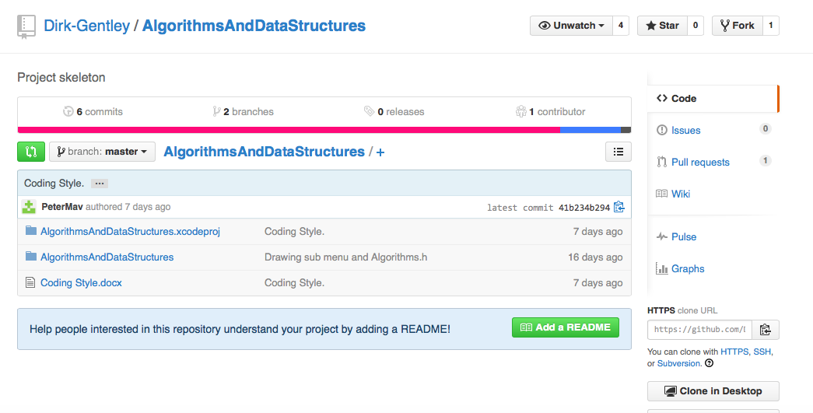go to your github.com to our repository

2.2.2.

2. click fork in top right corner.

3. this will create a new private repository that u can work on with out affecting the main repo.

4. open GitHub app

5. click the plus sign in the top left corner

6. a menu will open click Clone

7. a list of your accessible repositrys will be listed

8. select **AlgorithmsAndDataStructures.**

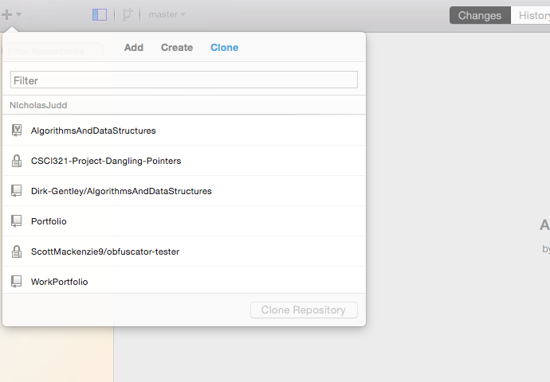

6. command click the repostire and open in finder to acces the code

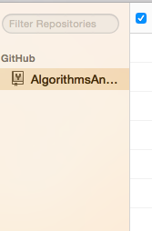

7. edit your code as needed

8. once code is editied you will see this

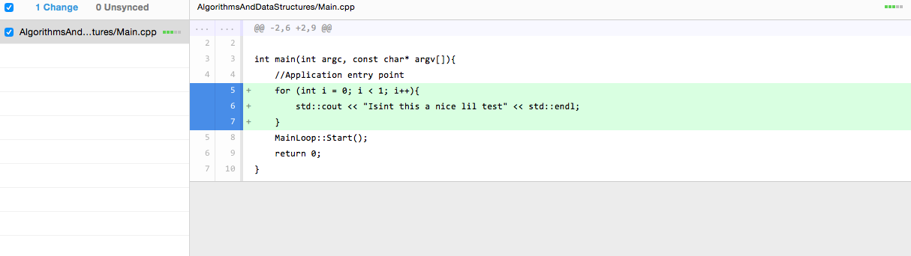

this wil show exactly what code u have changed.

9. Now we need to commit our changes.

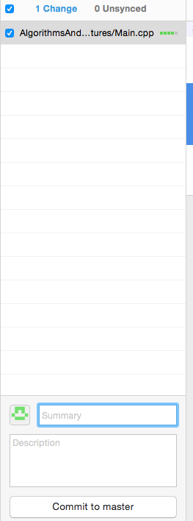

enter a summary title and a descripton of changes then click commit to master.

10.if you are happy with your changes sync your repostrie with command s.

11. once the syncing is completed we go to the main repostrys website

12. on the right hand side click pull request

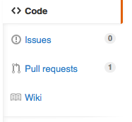

13. create a new pull request

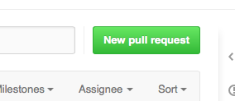

14 u need to click the hyperlink compare across forks

15. then change the head fork to your private repo

16.then click create pull request then create pull request